Daily Raingauges
 | Copper Raingauge  Code: 502-010  Attributes: Raingauge type = Copper  Standards:

Splayed-base daily raingauge
Code: 502-013
Attributes: Raingauge type = Splayed-base
Standards:

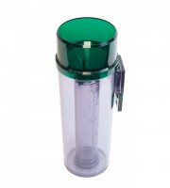 | De-Luxe Plastic Rain Gauge  Code: 460-010  Attributes: Raingauge type = Plastic  Standards:

Electronic Rain Gauge.
Code: 504-012
Attributes: Raingauge type = Electronic
Standards:

