Large Curing Tank
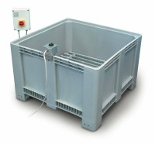 | Large Curing Tank C/W with Circulating Pump Heater/Thermostat Unit and Lower Rack  Code: 34-6575/01  Attributes: Description = Curing/soaking tank  Standards:

