In-situ Testing
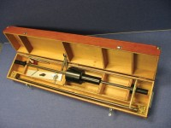 | Dynamic Cone Penetrometer 8Kg Hammer (Trl Design).  Code: 29-3720  Attributes: Description = Dynamic Cone Penetrometer, Weight, kg = 20  Standards:

 | Spare Cone for Dynamic Cone Penetrometer.  Code: 29-3720/10  Attributes: Description = Spare Cone for Dynamic Cone Penetrometer  Standards:

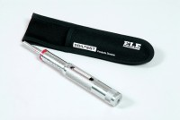 | Pocket Penetrometer.  Code: 29-3729  Attributes: Description = Pocket Penetrometer, Dimensions, diameter x length, ” = 3/4 x 6-3/8  Standards:

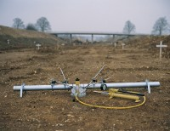 | Plate Bearing Apparatus Complete. 500kN Capacity  Code: 29-3800  Attributes: Description = Plate Bearing Apparatus, Pressure System Weight kg = 12.5  Standards: BS 1377, EN 1997-3, ASTM D1194, ASTM D1195, ASTM D1196

