Tilting Drum Mixer
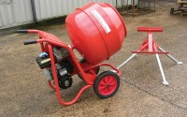 | Tilting Drum Concrete Mixer 120/90L/ (4/3Cu.Ft) Complete with Stand  Code: 34-3590/01  Attributes: Voltage Supply = 220 - 240 V AC, 50 Hz, 1 ph  Standards:

