Plastic Beam Form
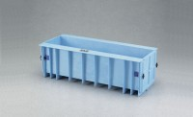 | Plastic Beam Form  Code: 34-5065  Attributes: Internal Dimensions dia x h, ” = 6 x 6 x 21, Description = Plastic Beam Form  Standards: ASTM C31, ASTM C78, ASTM C192, ASTM C293

