Particle Density (specific gravity) and Water Absorption for Fine Aggregates
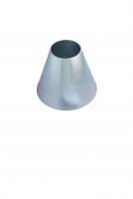 | Sand Absorption Cone.  Code: 42-1700  Attributes: Description = Sand Absorption Cone, Dimensions, diameter x height ” = 90 mm x 75 mm  Standards: BS 812, ASTM C128, AASHTO T84

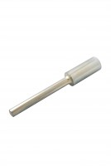 | Tamping Rod.  Code: 42-1720  Attributes: Description = Tamping Rod, Dimensions, diameter x height ” = 25.4 mm x 168 mm  Standards: BS 812, ASTM C128, AASHTO T84

