Wire Saw
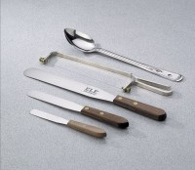 | Wire Saw  Code: 88-7600  Attributes: Construction = one piece metal with adjustable threaded screws, plated for rust resistance, Description = Wire Saw  Standards:

