ELE Flame Photometer
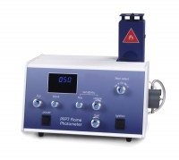 | ELE Flame Photometer  Code: 38-0200/01  Attributes: Description = Flame Photometer, Power Supply = 220 - 240 V AC, 50 - 60 Hz, 1 ph  Standards: EN 196-21, ASTM C114, TEST 17

 | Calcium Filter  Code: 38-0250  Attributes: Description = Calcium Filter  Standards: EN 196-21, ASTM C114, TEST 17

Barium Filter
Code: 38-0260
Attributes: Description = Barium Filter
Standards: EN 196-21, ASTM C114, TEST 17

Regulators for Natural Gas
Code: 38-0270
Attributes: Description = Natural Gas Regulator
Standards: EN 196-21, ASTM C114, TEST 17

Regulators for Propane Gas
Code: 38-0280
Attributes: Description = Propane Gas Regulator
Standards: EN 196-21, ASTM C114, TEST 17

Air Compressor
Code: 38-0320/01
Attributes: Description = Air Compressor, Power Supply = 220 - 240 V AC, 50 - 60 Hz, 1 ph
Standards: EN 196-21, ASTM C114, TEST 17

