Volumetair
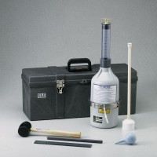 | Volumetair  Code: 34-3272  Attributes: Diameter, ” = 7.25, Description = Volumetair  Standards: ASTM C173

