Vicat Apparatus
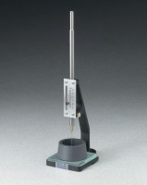 | Vicat Apparatus  Code: 38-2012  Attributes: Mold = Hard rubber; 70 mm base diam. x 60 mm top diam.<br>x 40 mm h., Description = Vicat Apparatus  Standards: ASTM C91, ASTM C187, ASTM C191, AASHTO T129, AASHTO T131

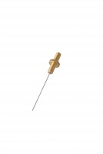 | ASTM Initial Set Needle  Code: 38-2620  Attributes: Description = ASTM Initial Set Needle  Standards: ASTM C187, ASTM C191

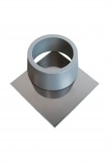 | ASTM Vicat Mould  Code: 38-2660  Attributes: Description = ASTM Vicat Mould  Standards: ASTM C187, ASTM C191

