Air/Water Pressure Systems - up to 1000 kPa
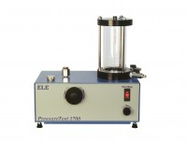 | Pressure Test 1700 Oil/Water Constant Pressure System 0 to 1700Kpa 220-240V 50/60Hz 1Ph.  Code: 26-1800/01  Attributes: Description = Pressure Test 1700 Oil/Water Constant Pressure System, Power Supply = 220 - 240 V AC, 50 - 60 Hz, 1 ph  Standards:

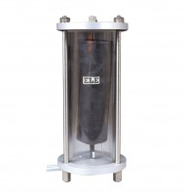 | Bladder-Type Air/Water Pressure Assembly. 1000 Kpa Maximum Working Pressure.  Code: 26-1746  Attributes: Description = Bladder-type air/water pressure assembly, Weight, kg = 5.6  Standards:

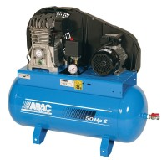 | Air Compressor  Code: 83-1730/01  Attributes: Working Pressure, kPa = 700, Description = Air Compressor Unit  Standards:

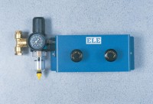 | Pneumatic Pressure Reducing Panel. Provides Two Independent Pressure Outlets 1000 Kpa Max.  Code: 26-1760  Attributes: Description = Pneumaticpressure reducing panel, Weight, kg = 4  Standards:

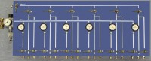 | Six-Way Pneumatic Pressure Control Panel.  Code: 26-1872  Attributes: Description = Six-Way Pneumatic Pressure Control Panel  Standards:

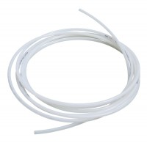 | Nylon Tubing 30 Metre Length.  Code: 26-1769  Attributes: Description = Nylon tubing, Weight, kg = 2  Standards:

Air Compressor
Code: 83-1735/01
Attributes: Description = Air Compressor Unit, Working Pressure, kPa = 1,000
Standards:

 | Replacement Bladder Wide Neck (38mm Id)  Code: 26-1746/10  Attributes: Description = Replacement bladder  Standards:

