Load Frames
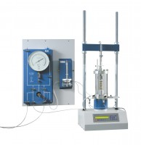 | Digital Tritest 50  Code: 25-3518/01  Attributes: Description = Digital Tritest 50 Load Frame 220-240 V AC, CBR Penetration = Yes, Unconfined Compression = Yes, Unconfined Compression = Yes, Consolidated Undrained = Yes, Consolidated Drained = Yes, Capacity, lbf = 11,200  Standards: BS 1377-7, BS 1377-8, BS 1924-2, ASTM D1883, ASTM D2166, ASTM D2850, ASTM D4767, ASTM D7181, AASHTO T99, AASHTO T134, AASHTO T135, AASHTO T136, AASHTO T180, AASHTO T193, AASHTO T208, AASHTO T296, AASHTO T297

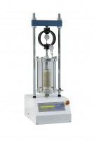 | MultiPlex 50 Load Frame  Code: 25-3700/01  Attributes: Description = MultiPlex 50 Load Frame, CBR Penetration = Yes, Unconfined Compression = Yes, Unconfined Compression = Yes, Voltage Supply = 220-240 V 50/60 Hz, Consolidated Undrained = -, Consolidated Drained = -, Power Supply = 220 - 240 V AC, 50 - 60 Hz, 1 ph, Marshall stability and flow = Yes  Standards: EN 12697-34, BS 598, BS 1377, BS 1924, ASTM D1883, EN 12697-23, EN 12697-24, EN 13286-47, AASHTO T193, ASTM D2850, ASTM D4767, AASHTO T296, AASHTO T297

