Concrete Mortar Penetrometer
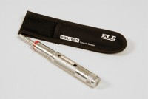 | Pocket Concrete Penetrometer  Code: 38-2695  Attributes: Description = Pocket Concrete Penetrometer, Dimensions, diam. X length, ” = 3/4” (19 mm) diam. x 7” (178 mm) long.  Standards: ASTM C187, ASTM C191, ASTM C780

