Capping Compound Warming Pots
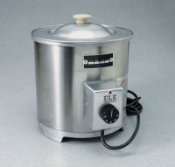 | Capping Compound Warming Pots 220vAC  Code: 34-6125/01  Attributes: External Dimensions dia x height, ” = 9 x 10, Description = Capping Compound Warming Pots 220vAC  Standards:

Capping Compound Warming Pots 110vAC
Code: 34-6125/02
Attributes: External Dimensions dia x height, ” = 9 x 10, Description = Capping Compound Warming Pots 110vAC
Standards:

 | Capping Ladle  Code: 81-0701  Attributes: Dimensions, l x w x h, ” = 0.15 cu ft, Description = Capping Ladle  Standards:

