Floating Ring Consolidometer
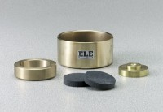 | 2.5" Floating Ring Consolidometer  Code: 25-0530  Attributes: Porous Stones dimensions diam x thick, ” = 2-15/32 x 1/2, Description = 2.5″ Floating Ring Consolidometer  Standards:

Porous Stone 2-15/32" dia.
Code: 25-0530/10
Attributes: Porous Stones dimensions diam x thick, ” = 2-15/32 x 1/2, Description = Porous Stone 2-15/32″ dia.
Standards:

Specimen Ring 2.5"
Code: 25-0533
Attributes: Specimen Ring = Machined Brass, Description = Specimen Ring 2.5″
Standards:

