Modified Compaction Mould
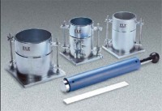 | Modified Compaction Mould  Code: 24-9098  Attributes: Dimensions, diameter x length, ” = 6x4.584, Description = Modified Compaction Mould  Standards: ASTM D698, ASTM D1557, AASHTO T99, AASHTO T180

