Direct/Residual Shear Apparatus
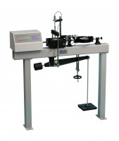 | Digital Direct/Residual Shear Apparatus Complete with Lever Loading Assembly. 110-120V 50/60Hz 1Ph.  Code: 26-2114/02  Attributes: Voltage Supply = 110-120V 50/60Hz, Description = Digital Direct/Residual Shear Apparatus, Vertical Load, lbf = 2,200  Standards: ASTM D3080, AASHTO T236

Digital Direct/Residual Shear Apparatus Complete with Lever Loading Assembly. 220-240V 50/60Hz 1Ph.
Code: 26-2114/01
Attributes: Description = Digital Direct/Residual Shear Apparatus, Voltage Supply = 220-240 V 50/60 Hz, Vertical Load, lbf = 2,200
Standards: ASTM D3080, AASHTO T236, BS 1377, EN 1997-2

