Dial Thermometers
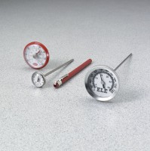 | Dial Thermometer, 25° to 125°F x 1.0° and -5° to 50°C x 0.5°.  Code: 88-4450  Attributes: Dimensions, diameter x length, ” = 1-3/4 x 8, Description = Dial Thermometer, 25° to 125°F x 1.0° and -5° to 50°C x 0.5°.  Standards:

Dial Thermometer, 0° to 220°F x 2.0° and -10° to 100°C x 1.0°.
Code: 88-4452
Attributes: Dimensions, diameter x length, ” = 1-3/4 x 8, Description = Dial Thermometer, 0° to 220°F x 2.0° and -10° to 100°C x 1.0°.
Standards:

Dial Thermometer, 50° to 300°F x 2.0° and 10° to 150°C x 1.0°.
Code: 88-4454
Attributes: Dimensions, diameter x length, ” = 1-3/4 x 8, Description = Dial Thermometer, 50° to 300°F x 2.0° and 10° to 150°C x 1.0°.
Standards:

Dial Thermometer, 50° to 500°F x 5.0° and 5° to 260°C x 5.0°.
Code: 88-4456
Attributes: Dimensions, diameter x length, ” = 1-3/4 x 8, Description = Dial Thermometer, 50° to 500°F x 5.0° and 5° to 260°C x 5.0°.
Standards:

