Master Humidifier
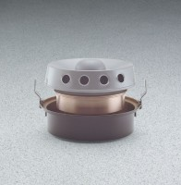 | Master Humidifier  Code: 34-6775/02  Attributes: Operating Water Pressure, psig = 10-100, Description = Master Humidifier  Standards:

 | Humidistat Controller  Code: 34-6777/02  Attributes: Rated Power = 110vAC, 60 Hz, 1ø., Description = Humidistat Controller  Standards:

