Sample Ejector
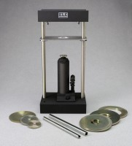 | Sample Ejector  Code: 23-4085  Attributes: Dimensions w x d x h, ” = 10-1/2 x 8 x 22-1/2, Description = Sample Ejector  Standards:

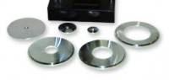 | 2" Ejector Head and Adapter Plate  Code: 23-4085/12  Attributes: Description = 2" Ejector Head and Adapter Plate  Standards:

3" Ejector Head and Adapter Plate
Code: 23-4085/13
Attributes: Description = 3" Ejector Head and Adapter Plate
Standards:

2.5" Ejector Head and Adapter Plate
Code: 23-4085/10
Attributes: Description = 2.5" Ejector Head and Adapter Plate, Weight, lbs = 3.44
Standards:

