Forced Convected Ovens
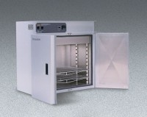 | Forced Convected Oven - 6.9 cu. ft. capacity - 120V  Code: 88-0156/02  Attributes: Thermostat = Digital, Description = Forced Convected Oven - 6.9 cu. ft. capacity - 120V  Standards:

Forced Convected Oven - 18 cu. ft. capacity - 240V
Code: 88-0161/01
Attributes: Thermostat = Digital, Description = Forced Convected Oven - 18 cu. ft. capacity - 240V
Standards:

Forced Convected Oven - 27 cu. ft. capacity - 240v
Code: 88-0166/01
Attributes: Thermostat = Digital, Description = Forced Convected Oven - 27 cu. ft. capacity - 240v
Standards:

