Plastic Limit Set
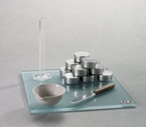 | Plastic Limit Set  Code: 2810E  Attributes: Weight, lbs = 6.46, Description = Plastic Limit Set  Standards: ASTM D4318, AASHTO T90

