Concrete Cylinder Compressometer-Extensometer
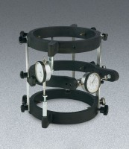 | Concrete Cyl. Compressometer - English  Code: 37-5625  Attributes: Dial Indicators = two included, Description = Concrete Cyl. Compressometer - English  Standards: ASTM C469

Concrete Cyl. Compressometer - Metric
Code: 37-5626
Attributes: Dial Indicators = two included, Description = Concrete Cyl. Compressometer - Metric
Standards: ASTM C469

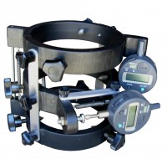 | Concrete Cyl. Compressometer - Digital Indicators  Code: 37-5628  Attributes: Description = Concrete Cyl. Compressometer - Digital Indicators, Indicator = 2, Digital  Standards: ASTM C469

