Sand Equivalent Value
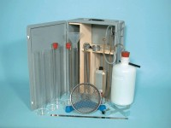 | Sand Equivalent Apparatus ASTM Aashto with Carrying Case.  Code: 24-4919  Attributes: Description = Sand equivalent apparatus ASTM D2419  Standards: ASTM D2419, AASHTO T176

 | 5 Litre Syphon Assembly with Connection for 5mm Id Tubing.  Code: 24-4925  Attributes: Description = Syphon assembly  Standards: ASTM D2419, AASHTO T176

Calcium Chloride 2.5Kg.
Code: 24-4930
Attributes: Description = Calcium chloride, Weight, kg = 2.5
Standards: ASTM D2419, AASHTO T176

Formaldehyde 36% Aqueous Solution 2.5 Litre.
Code: 24-4932
Attributes: Description = Formaldehyde
Standards: ASTM D2419, AASHTO T176

Glycerol Analar 2.5 Litre
Code: 24-4934
Attributes: Description = Glycerol analar
Standards: ASTM D2419, AASHTO T176

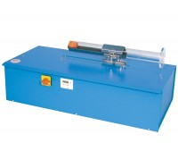 | Motorised Sand Equivalent Shaker ASTM. 220-240V 50Hz 1Ph.  Code: 24-4945/01  Attributes: Description = Motorised sand equivalent shaker, Power Supply = 220 - 240 V AC, 50 Hz, 1 ph  Standards:

