Regular Augers
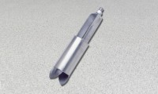 | Regular Auger  Code: 23-1380  Attributes: Diameter, ” = 3 - 1 / 4, Description = Regular Auger  Standards:

 | Auger Extension 60"  Code: 23-1389  Attributes: Weight, lbs = 1, Description = Auger Extension 60″  Standards:

