Precision Air Entrainment Meter
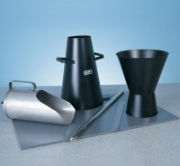 | Tamping Rod 16mm Dia X 600mm Long Hemispherical At Both Ends.  Code: 34-0130  Attributes: Description = Tamping Rod, Weight, kg = 0.95 kg  Standards:

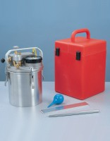 | Air Entrainment Meter B Type Complete with Carrying Case. Supplied with Aluminium Tamping Bar.  Code: 34-3265  Attributes: Description = Air Entrainment Meter - B Type, External Dimensions dia x height, ” = 9.75 x 13.25  Standards: ASTM C231, AASHTO T152

 | Compacting Bar 25mm Sq X 380mm  Code: 34-2910  Attributes: Description = Compacting bar  Standards:

