Compression Tension Machine
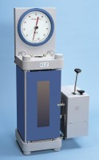 | 1000/500kN Motorised Compression/Tension Machine (complete with grips) 220-240V 50/60Hz 1Ph.  Code: 36-1410/01  Attributes: Description = Motorised Compression/Tension Machine, Voltage Supply = 220-240 V 50/60 Hz  Standards:

