Percentage Refusal Density (PRD)
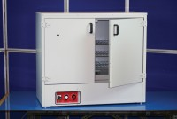 | 225 Litre Drying Oven  Code: 78-1250/01  Attributes: Description = Drying Oven, Capacity, litres = 225, No. of shelves supplied = 3, No. of shelf positions = 4, Temperature Fluctuation = +/- 0.75 °C, Internal Dimensions (length x width x height) mm = 440 x 920 x 600 mm, Temperature Range °C = 0 - 200 °C, Voltage Supply = 220-240 V 50/60 Hz  Standards: EN 12697-32, EN 13280-4, BS 598-104, BS 1377

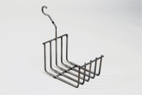 | Cradle  Code: 34-8105  Attributes: Description = Cradle, Weight, lbs = 1.24  Standards: EN 12697-32, EN 13280-4, BS 598-104

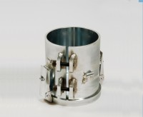 | PRD Split Mould and Baseplate  Code: 47-0450  Attributes: Description = PRD Split Mould and Baseplate, Weight, kg = 10.7  Standards: EN 12697-32, EN 13280-4, BS 598-104

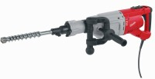 | Vibrating Hammer  Code: 47-0455/01  Attributes: Description = Vibrating Hammer, Power Supply = 220 - 240 V AC, 50 - 60 Hz, 1ph  Standards: EN 12697-32, EN 13280-4, BS 598-104

 | 300 mm Shank  Code: 47-0480  Attributes: Description = 300 mm Shank  Standards: EN 12697-32, EN 13280-4, BS 598-104

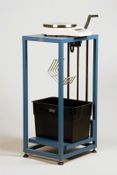 | Buoyancy Balance  Code: 34-8100/09  Attributes: Description = Buoyancy Balance, Power Supply = 110 - 240 V AC, 50 - 60 Hz, 1 ph  Standards: EN 12697-32, EN 13280-4, BS 598-104

