Pocket Shearmeter
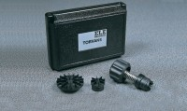 | Pocket Shearmeter with 3 Vanes 0 to 1Kgf/Cm2 X 0.5Kgf/Cm2.  Code: 26-2261  Attributes: Description = Torvane Shear Device, Dial Scale = 1 kg/sq. cm (tons/sq. ft.) x 0.05 subdivisions.  Standards:

