Concrete Test Hammer
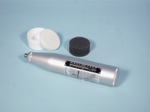 | Standard Concrete Test Hammer  Code: 35-1480  Attributes: Description = Standard Concrete Test Hammer, Accuracy, % = 15  Standards: ASTM C805

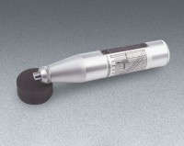 | Concrete Test Hammer - English  Code: 35-1475  Attributes: Accuracy, % = 15, Description = Concrete Test Hammer - English  Standards: ASTM C805

 | Rubbing Stone  Code: 35-1475/10  Attributes: Weight, lbs = 0.48, Description = Rubbing Stone  Standards: ASTM C805

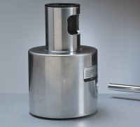 | Testing Anvil  Code: 35-1530  Attributes: Description = Testing Anvil, Weight, lbs = 37.06  Standards: ASTM C805

