Penetration and measurement
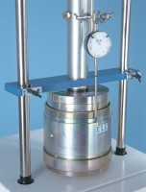 | Penetration Piston  Code: 24-9182  Attributes: Description = Penetration piston, Weight, kg = 3.7  Standards:

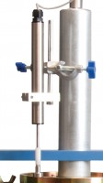 | CBR Penetration Transducer 50mm Travel Fitted with 5 Pin Din Plug.  Code: 27-1705  Attributes: Description = Penetration transducer, Mounting Bracket = Included  Standards:

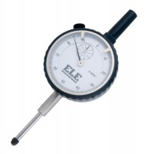 | Penetration/Swell Dial Gauge ASTM.  Code: 24-9184  Attributes: Description = Penetration/swell gauge ASTM  Standards:

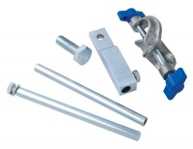 | Bracket and Adaptor. Dual Purpose Mounting Bracket for CBR Penetration Gauges EL24-9184/EL24-9186  Code: 24-9188  Attributes: Description = Bracket and adaptor  Standards:

Penetration Dial Gauge BS
Code: 24-9186
Attributes: Description = Penetration dial gauge - BS
Standards:

Cbr Penetration Piston (Adjustable).
Code: 24-9183
Attributes: Description = Penetration Piston - with adjustment
Standards:

