Flakiness Sieves and Gauges
 | Flakiness Gauge.  Code: 42-0410  Attributes: Weight, kg = 0.06, Description = Flakiness Gauge  Standards: BS 812

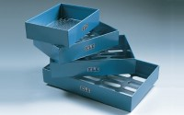 | Set of Flakiness Sieves Comprising 1 Ea 4.9mm 7.2mm 10.2mm 14.4mm 19.7mm 26.3mm and 33.9mm  Code: 42-0600  Attributes: Description = Set of Flakiness Sieves  Standards: BS 813

