Filter Paper
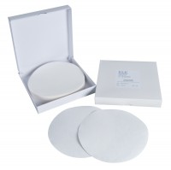 | Filter Paper Equivalent to Whatman No 5 150mm Dia Box of 100.  Code: 24-9250  Attributes: Description = Filter papers - 150 mm diameter, Size (height x width x diameter) cm = 5.9  Standards: ASTM D1883, AASHTO T193

