Laboratory CBR, Hand-Operated
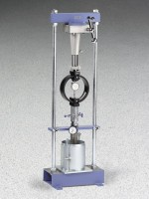 | Laboratory CBR, Hand Operated (English)  Code: 2420E  Attributes: Weight, lbs = 337, Description = Laboratory CBR, Hand Operated (English)  Standards: ASTM D1883, AASHTO T193

Laboratory CBR, Hand Operated (Metric)
Code: 2421E
Attributes: Weight, lbs = 337, Description = Laboratory CBR, Hand Operated (Metric)
Standards: ASTM D1883, AASHTO T193

