Accessories for ASTM and Proctor compaction
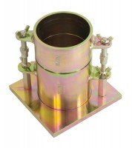 | Proctor Mould 1/30 Ft3.  Code: 24-9060  Attributes: Description = Proctor mould, Guide Sleeve = Steel  Standards: ASTM D558, ASTM D559, ASTM D560, ASTM D698, ASTM D1557, AASHTO T99, AASHTO T134, AASHTO T135, AASHTO T136, AASHTO T180

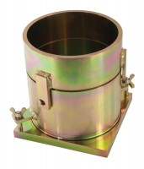 | ASTM Compaction Mould 152mm.  Code: 24-9066  Attributes: Description = ASTM/Modified Proctor compaction mould, Construction = Steel  Standards: ASTM D698, ASTM D1557, AASHTO T99, AASHTO T180

