Sample Preparation
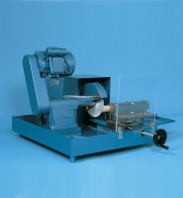 | Gsp210/250 Core Trimmer & Cut Off Machine Supplied with Coolant Pump Unit  Code: 70-0250/01  Attributes: Description = GSP 210/250 Core Trimmer & Cut Off Machine, Power Supply = 220 - 240 V AC, 50 Hz, 1 ph  Standards:

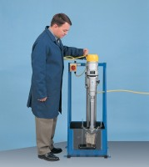 | Rock Core Drill Supplied with 2 X Nx Core Drill Bit  Code: 70-0095/01  Attributes: Description = Rock Core Drill, Power Supply = 220 - 240 V AC, 50 Hz, 1 ph  Standards:

