Soil Colour Charts
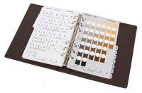 | Soil Colour Chart Set  Code: 23-7150  Attributes: Weight, kg = 0.91, Description = Soil Colour Chart Set  Standards:

