Tri-Flex 2 Water De-Airing Tank System
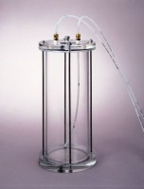 | Tri-Flex 2 Water De-airing Tank System  Code: 25-0698  Attributes: Capacity, gals = 1.4, Description = Tri-Flex 2 Water De-airing Tank System  Standards: ASTM D2850, ASTM D4767, ASTM D7181, ASTM D5084, AASHTO T296, AASHTO T297

