Proving Ring Penetrometer
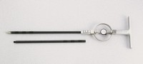 | Proving Ring Penetrometer  Code: 29-3739  Attributes: Extension Rod Dimensions diam x l, ” = 3/4 x 36, Description = Proving Ring Penetrometer  Standards:

