Calibration Devices
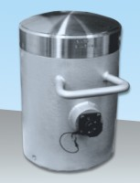 | 2000 kN Capacity Calibration Load Cell with Hand-Held Readout  Code: 37-8315  Attributes: Description = 2000 kN capacity calibration device  Standards:

 | 3000 kN Load Calibration Device Complete with Hand Held Readout Unit  Code: 37-8400  Attributes: Description = 3000 kN capacity calibration device  Standards:

