Mortars and Pestles
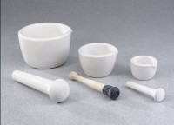 | Mortar & Pestle - 225 ml Capacity, 7" Length  Code: 88-6802  Attributes: Construction = Porcelain., Description = Mortar & Pestle - 225 ml Capacity, 7″ Length  Standards:

Mortar & Pestle - 650 ml Capacity, 9" Length
Code: 88-6804
Attributes: Construction = Porcelain., Description = Mortar & Pestle - 650 ml Capacity, 9″ Length
Standards:

