Core Cutter Apparatus
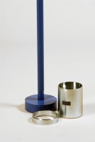 | Core Cutter 100mm Id By 130mm Long.  Code: 29-5300  Attributes: Description = Core Cutter 100mm, Internal diameter mm = 100  Standards: BS 1377

 | Driving Dolly for EL 29-5300  Code: 29-5320  Attributes: Description = Driving Dolly, Weight, kg = 0.34  Standards: BS 1377

Driving Rammer for EL 29-5320
Code: 29-5340
Attributes: Description = Driving Rammer, Weight, kg = 13
Standards: BS 1377

