Test Bar Moulds
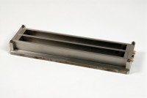 | Two Gang Prism Mould Produces 1 Inch Square X 11 1/4 Inch Long Specimen (10 Inch Gauge Length)  Code: 34-8544  Attributes: Description = Two Gang Prism Mould 1" x 11 1/4", Gauge Length = 10” (254 mm) between inner ends of embedded contact points.  Standards: ASTM C141, ASTM C151, ASTM C157, ASTM C227, ASTM C490, ASTM C531, AASHTO T107

 | Single mould  Code: 34-8545  Attributes: Gauge Length = 10” (254 mm) between inner ends of embedded contact points., Description = Single mould  Standards: ASTM C141, ASTM C151, ASTM C157, ASTM C227, ASTM C490, ASTM C531, AASHTO T107

Contact Points
Code: 34-8548
Attributes: Description = Contact Points
Standards:

