Sulphur Compound Method
 | Flake Capping Compound to ASTM C617 22Kg  Code: 34-6100  Attributes: Description = Flake Capping Compound, Melting Range, °F = 230-240  Standards: ASTM C617, AASHTO T231

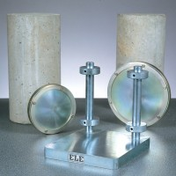 | Cylinder Capping Frame Complete with 100mm and 150mm Dia Capping Plates.  Code: 34-6031  Attributes: Description = Cylinder Capping Frame, Weight, kg = 10  Standards:

