Flexural and Transverse Testing
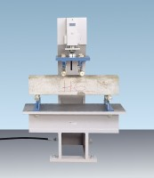 | 100kN Flexural and Transverse (Flags) Frame. Supplied Without Specimen Bearers and Fitting Kit.  Code: 37-6140  Attributes: Description = 100kN Flexural and Transverse (Flags) Frame  Standards:

 | Specimen Bearer Assembly  Code: 37-6330  Attributes: Description = Specimen Bearer Assembly for flexural testing of beams  Standards:

Specimen Bearers for Testing KerBS. Used on 37-6140 Flags Frame.
Code: 37-6362
Attributes: Description = Specimen Bearers for transverse testing of kerbs
Standards:

Specimen Bearers for Testing Flags. Used on 37-6140 Flags Frame.
Code: 37-6364
Attributes: Description = Specimen Bearers for transverse testing of flags
Standards:

