Plastic Funnels
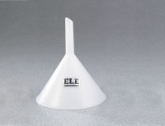 | Plastic Funnel - 2" top diam.  Code: 88-7200  Attributes: Construction = Conventional polyethylene; non-toxic, non-contaminanting; withstands nearly all chemicals at room te, Description = Plastic Funnel - 2″ top diam.  Standards:

Plastic Funnel - 4" top diam.
Code: 88-7202
Attributes: Construction = Conventional polyethylene; non-toxic, non-contaminanting; withstands nearly all chemicals at room te, Description = Plastic Funnel - 4″ top diam.
Standards:

Plastic Funnel - 6" top diam.
Code: 88-7204
Attributes: Construction = Conventional polyethylene; non-toxic, non-contaminanting; withstands nearly all chemicals at room te, Description = Plastic Funnel - 6″ top diam.
Standards:

