Compaction Pedestal
 | Compaction Mould Holder  Code: 45-6414  Attributes: Description = Compaction Mould Holder  Standards: ASTM D6926, AASHTO T245

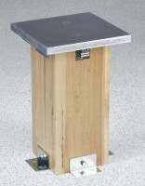 | Compaction Pedestal  Code: 45-6416  Attributes: Installation = 4 angle brackets for mounting to concrete slab., Description = Compaction Pedestal  Standards: ASTM D6926, AASHTO T245

