Force measurement
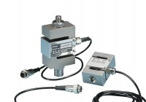 | 50kN S-type Load Cell  Code: 27-1559  Attributes: Description = S-type load cell - 50 kN, Value of CBR % = ALL, Environmental Protection = IP65, Force Capacity, kN = 50  Standards: EN 12697-34

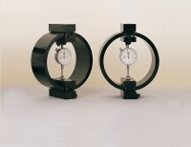 | Clamped Boss Load Ring - 2.0 kN  Code: 78-0060  Attributes: Description = Load ring - 2 kN, Force Capacity, kN = 2, Value of CBR % = Up to 8%, Capacity, lbf = 450, Capacity kN = 2.0  Standards: BS 1377, ASTM D3080

Clamped Boss Load Ring - 10.0 kN
Code: 78-0460
Attributes: Description = Load ring - 10 kN, Value of CBR % = 8% to 40%, Weight, lbs = 10.54, Force Capacity, kN = 10
Standards:

Clamped Boss Load Ring - 28.0 kN
Code: 78-0760
Attributes: Description = Load ring - 28 kN, Load device type = Load ring, Force Capacity, kN = 28, Value of CBR % = Average range of CBR, Overall Height, mm = 248
Standards:

50kN Load Measuring Ring
Code: 78-0860
Attributes: Description = Load ring - 50 kN, Value of CBR % = Above 40%, Overall Height, mm = 248, Force Capacity, kN = 50, Load device type = Load ring
Standards: EN 12697-34

