General Purpose Compression Machines
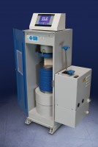 | ADR Touch 1500 Compression Machine with Digital Readout.  Code: 36-0720/01  Attributes: Voltage Supply = 220-240 V 50/60 Hz, Force Capacity, kN = 1500, Maximum Ram Travel mm = 50 mm  Standards:

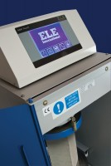 | ADR Touch 2000 Standard Compression Machine with Digital Readout.  Code: 36-3090/01  Attributes: Voltage Supply = 220-240 V 50/60 Hz, Force Capacity, kN = 2000, Maximum Ram Travel mm = 50 mm  Standards:

