ASTM Liquid Limit Set
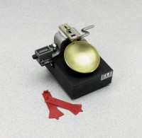 | Liquid Limit Set  Code: 2800E  Attributes: Weight, lbs = 6, Description = Liquid Limit Set  Standards: ASTM D4318

